CONGRATULATIONS!!!!!!
You have just won a free trip to Quebec!
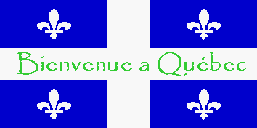
Introduction

You and your family have just won an all –expenses –paid virtual trip to Quebec. You will be checking out the traditional food of the Quebec culture, sports and recreation activities available at the beautiful Mont Sainte Anne, historical Quebec City, and the famous winter Carnival!

The Task

You need to keep a scrapbook of your journey. This scrapbook will be used to promote Quebec's unique culture. You will need to create your scrapbook as either a Power Point or Smart board presentation.

You will need to include INFORMATION and PICTURES/ PHOTOS for each of the following:

FOOD CUSTOMS /10
- Most common foods for breakfast, lunch , dinner
- Foods for celebrations and holidays
- Other info about food/ snacks ect
Website: http://www.foodbycountry.com/Algeria-to-France/Canada-French-Canadians.html

CARNIVAL /10
- What is it and when and where does it take place?
- Describe 3 family activities you did. Include photos of each activity
Website: http://www.carnaval.qc.ca/

VISIT QUEBEC CITY ATTRACTIONS /10
- Tour the Parliament buildings. Describe 2 things that were the most fascinating to see. Include photos of each.
- Go to the Citadel. What is it? Include a photo.
- Go to Battlefields Park. What is the other famous name of this place? What happened here? Include a photo.
Website; http://www.telegraphe.com/introen.html?q

SPORTS AND RECREATION: VISIT MONT SAINTE ANNE /10
- Pick 3 activities you would like to take part in.
- Describe each activity you did and include information about the activity. Also include pictures.
Website:
http://www.chateaumontsainteanne.com/en/services/activities
Presentation Mark: /10

You will also be given a mark on how authentic your scrapbook is. Think about the VOICE you use. Example: "Today we went to……….It was so fun……I can't believe……. I really enjoyed the ……"

TOTAL MARKS ______ / 50

